**Activity log**

**Week 1:**

First week I did my investigation and decided which features were most important to my app

**Week 2:**

This week I made microbit code for user to input variables through microbit.

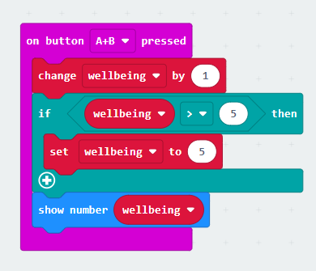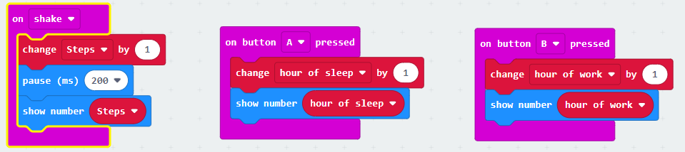

**Week 3**

In this week I made microbit code which sends my variables to the second microbit and prints to thonny

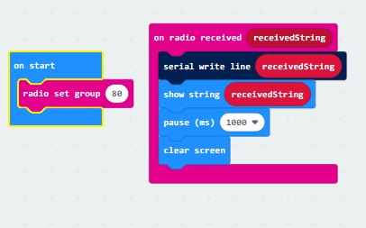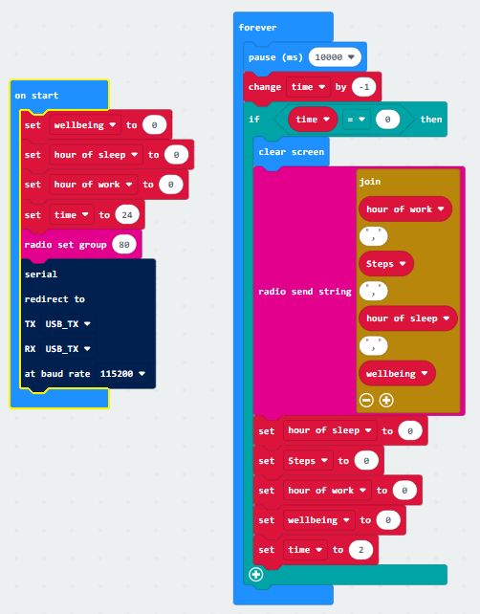

**Week 4**

I created python code which sends information from second microbit and stores it on firebase. Also made code to convert number value to string value for firebase.eg.1=very sad

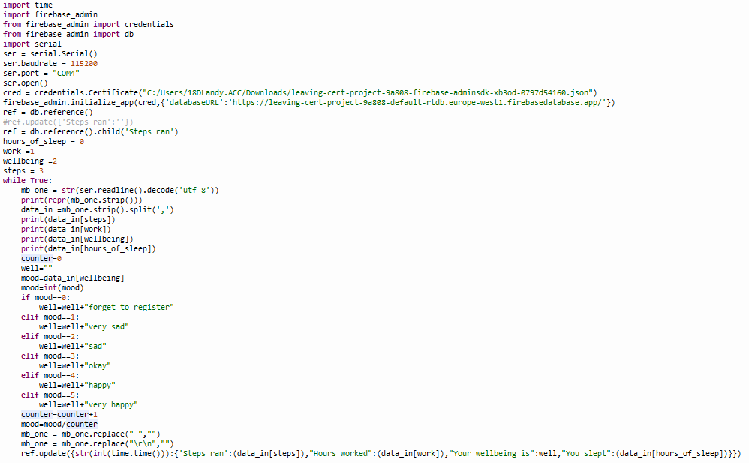

**Week 5**

I created code to add all values in a list for both sleep and worked and created a Nworked and Nslept variable to store average value.

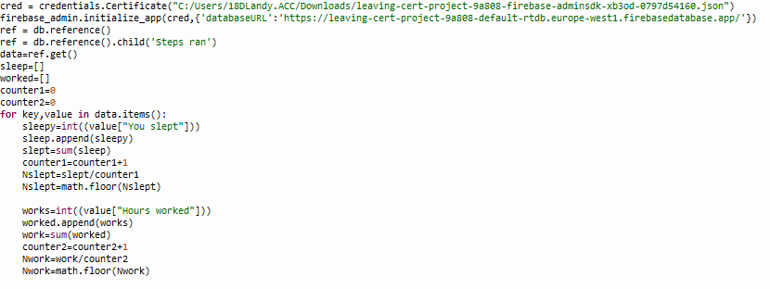

**Week 6**

I implemented same principle as before but added steps

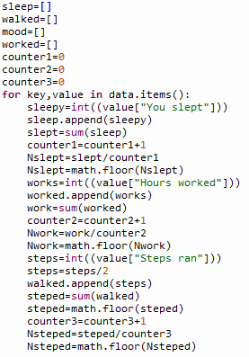

**Week 7**

I implemented a code that got average mood and also added all of mood into a string

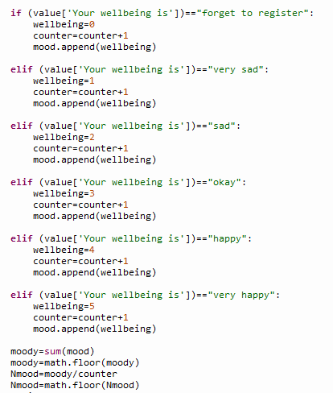

**Week 8**

I printed out to user what there average productivity with there current sleep and exercise habits and separate each child value into a variable using a dictionary.

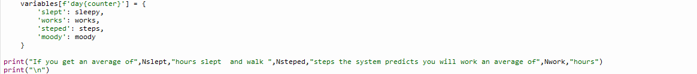

**Week 9**

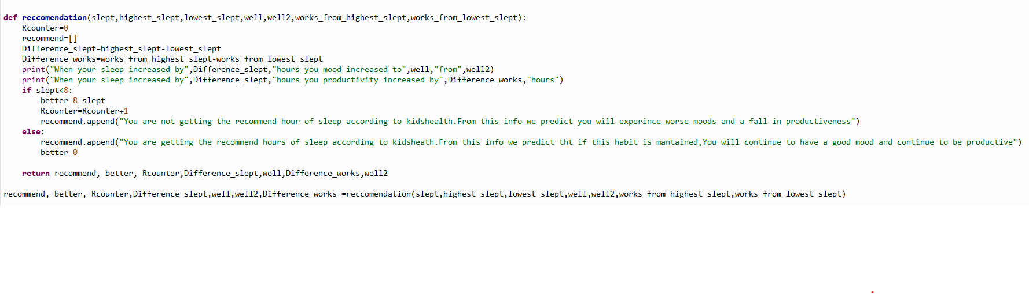  ***Important piece of code***

This function is an important code as it answers one of my what if questions. function receive 7 parameters with two different data types (being string and integer). The code finds difference between the highest and lowest sleep and stores it in a variable Difference_slept. It also creates a variable Difference works which stores the difference of work between work on the day of highest sleep and work on day of lowest sleep. It then prints the difference of work when your hours increased by Difference_slept and how your mood changed when your sleep increased by Difference_slept. It then checks if the slept value is less then 8. If it is it runs a code telling users that they are not getting enough sleep and they need to improve their habits or they will experience worse mood and being less productive. It also stores how far user is off from getting 8 hours sleep by taking slept away from 8 and storing it in a variable called better. It also adds one to Rcounter which results in this code running:

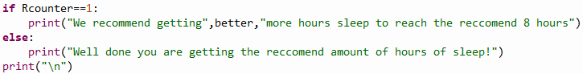

This tells user how many more hours they need to get in order to be in line with kidshealth recommendation. If slept value is over 8 it tells user that they are getting enough sleep and outlines benefit of this sleep. As Rcounter never runs this means it print else congratulating user on reaching the recommend hours.

***Issue I faced***

A big issue I faced was trying to take an individual value from the child from firebase. After trying a few ways but I was struggling on how to call a certain child and how I was going to get that code run for the amount of inputs I had. I landed on day starting at day1, day2, day3 etc which would continue to increase for each input it would receive. 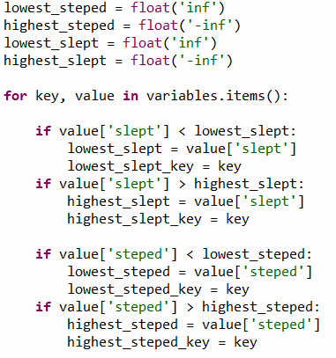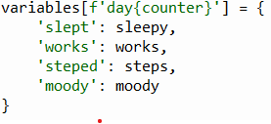

This allowed me to refer to specific days and also take information from specific days. I also then could use a loop that would loop through the dictionary to find which variable had the highest and lowest sleep value which ended up being an essential part of my what if questions and its functions.

***Unit test***

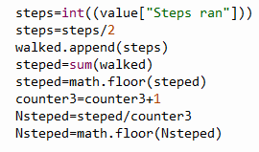

I unit tested this piece of code and initially ran into an error I wasn’t expecting for my data to have so many decimals .To fix this issue I added math.Floor which rounds down the variable so I can avoid data with multiple decimals effecting the results of my what if questions.

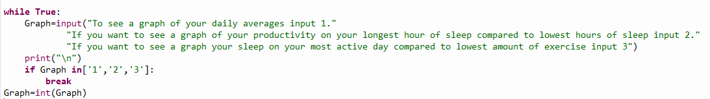

When I was developing this code and tried unit tested the code I realised if user inputted a string the code to crash so to fix this I added a while loop so if user doesn’t enter a valid input of 1,2 or 3 it will rerun until user adds a valid number.



I unit tested this code by putting in both possible inputs being more and less then 8 hours and checked to see if it gave me the correct recommendation. After testing I found the code did work as intended.